Link: https://itadminsbraindump.wordpress.com/2020/01/22/configure-nagios-email-notifications-in-aws-ec2-linux-server/

onfigure Nagios Email Notifications in AWS EC2 Linux Server

[Dharamvir's Braindump](https://itadminsbraindump.wordpress.com/author/sangramsystems/" \o "Posts by Dharamvir's Braindump)  [Brain Dump](https://itadminsbraindump.wordpress.com/category/brain-dump/)  January 22, 2020 3 Minutes

[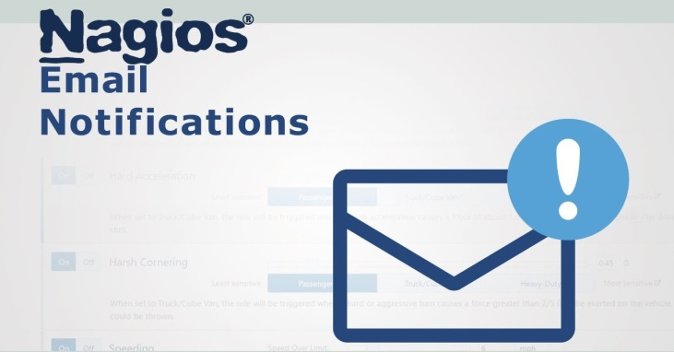](https://itadminsbraindump.files.wordpress.com/2020/01/nagios-email-notifications.jpg)

We have learnt Nagios Core installation [here](https://itadminsbraindump.wordpress.com/2020/01/21/configure-nagios-in-aws-ec2-linux-server). Now we need to configure Email Notifications for the same.

By default, please note that Nagios Core alone is not capable of sending emails if you not configure PostFIX or any SMTP Mail Client in the server.

So, For emails, I created a **Gmail ID** and provided **PostFIX** that information so that Nagios can send emails from this Gmail ID.

Let’s get started,

As root, run below command to install PostFIX and MailX utility

**sudo yum install postfix mailx**

**MailX** is a small binary program that is used by Nagios to send mail to the local Postfix mail server.

Now lets configure PostFIX

**vi /etc/postfix/main.cf**

and paste the following lines in the end:

relayhost = [smtp.gmail.com]:587

mynetworks = 127.0.0.0/8

inet_interfaces = loopback-only

smtp_use_tls = yes

smtp_always_send_ehlo = yes

smtp_sasl_auth_enable = yes

smtp_sasl_password_maps = hash:/etc/postfix/sasl_passwd

smtp_sasl_security_options = noanonymous

smtp_sasl_tls_security_options = noanonymous

smtp_tls_security_level = encrypt

smtp_generic_maps = hash:/etc/postfix/generic

Now as we written that login information is in **smtp_sasl_password_maps = hash:/etc/postfix/sasl_passwd** path so we need to fill that sasl_password file.

**vi /etc/postfix/sasl_passwd**

As it is not recommended to save passwords in plain text format so, for that Gmail provide “App Passwords” which is encrypted and safe to use and works same as passwords but you can use them in applications.

For this, Login to your **Gmail** and go to **Settings.**  
[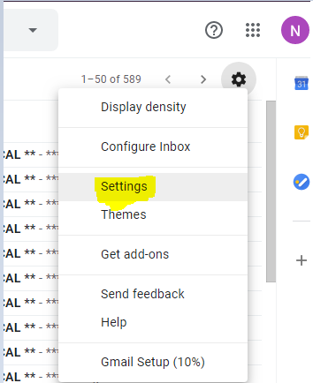](https://itadminsbraindump.files.wordpress.com/2020/01/nagios-email-notifications.png)

Then click on **Accounts and Import**, then click on **Other Google Account Settings**.

[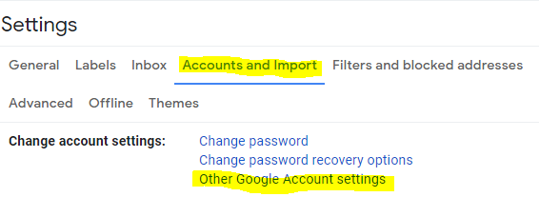](https://itadminsbraindump.files.wordpress.com/2020/01/nagios-core-email-notification-setup.png)

Click on **Security** and then Select **App Password**

[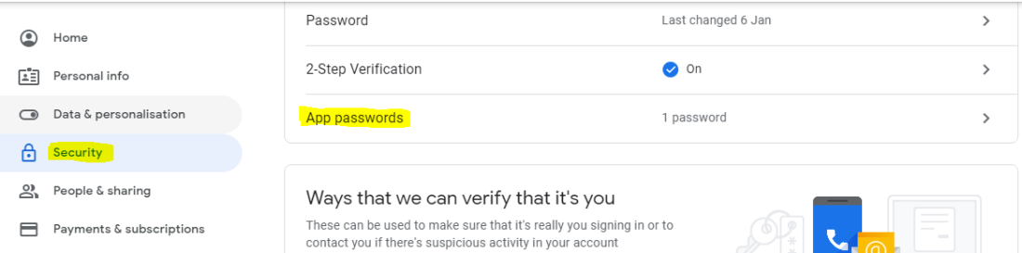](https://itadminsbraindump.files.wordpress.com/2020/01/nagios-postfix-configuration.png)

In this page select the device as **Unrecognised Device** or you can set any name here and click on **Generate**. Copy the **encrypted password** from here and then on server, create a new blank file

**vi /etc/postfix/sasl_passwd**

and paste the **Gmail ID** and **App Password** in below format:

**[smtp.gmail.com]:587** [**nagiosmail@gmail.com:isighuwxxxyyyyhjshdjjkjks**](mailto:nagiosmail@gmail.com:isighuwxxxyyyyhjshdjjkjks)

Now generate PostFIX lookup table

**postmap /etc/postfix/sasl_passwd**

Now change permission for password file

**chown root:postfix /etc/postfix/sasl_passwd**

**chmod 640 /etc/postfix/sasl_passwd**

we need to configure a **generic** file in order to be able to send emails as a valid user.

**vi /etc/postfix/generic**

Save and exit from file and change permissions too.

**chown root:root /etc/postfix/generic**

**chmod 0600 /etc/postfix/generic**

**postmap /etc/postfix/generic**

Now Change alias root to your email address.

**vi /etc/aliases**

Make the changes like below:

**mailer-daemon:  postmaster**

**postmaster:     root**

**root:           Nagiosmail@gmail.com**

save and exit and run below command for changes to take place.

**newaliases**

Restart PostFIX

**systemctl restart postfix.service**

Now PostFIX is ready to send emails. Test it by sending emails to your id

**echo "This is the body of the test email" | mail -s "This is the subject line" dharamvirsingh@gmail.com**

We need to configure **MailX** and **Nagios** now.

Modify **Commands.cfg**  for Nagios,

**vi /usr/local/nagios/etc/objects/commands.cfg**

and make changes as provided:

define command {

command_name    process-host-perfdata

command_line    /usr/bin/printf "%b" "$LASTHOSTCHECK$\t$HOSTNAME$\t$HOSTSTATE$\t$HOSTATTEMPT$\t$HOSTSTATETYPE$\t$HOSTEXECUTIONTIME$\t$HOSTOUTPUT$\t$HOSTPERFDATA$\n" >> /usr/local/nagios/var/host-perfdata.out

}

define command {

command_name    process-service-perfdata

command_line    /usr/bin/printf "%b" "$LASTSERVICECHECK$\t$HOSTNAME$\t$SERVICEDESC$\t$SERVICESTATE$\t$SERVICEATTEMPT$\t$SERVICESTATETYPE$\t$SERVICEEXECUTIONTIME$\t$SERVICELATENCY$\t$SERVICEOUTPUT$\t$SERVICEPERFDATA$\n" >> /usr/local/nagios/var/service-perfdata.out

}

Modify **contact.cfg** – Here we need to add email address where all the notification will go.

**vi /usr/local/nagios/etc/objects/contacts.cfg[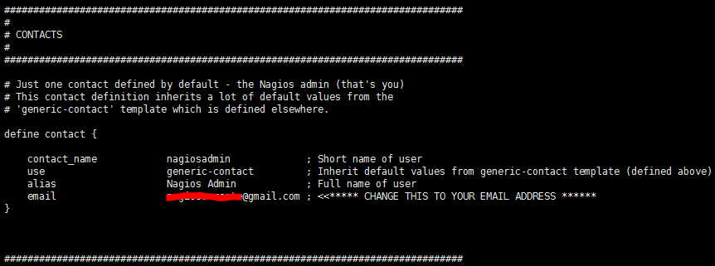](https://itadminsbraindump.files.wordpress.com/2020/01/nagios-command-cfg-postfix-mailx.png)**

Now change **Notifications Durations** to 10 Mins

**vi /usr/local/nagios/etc/objects/templates.cfg**

For service Notifications, modify red highlighted entry

[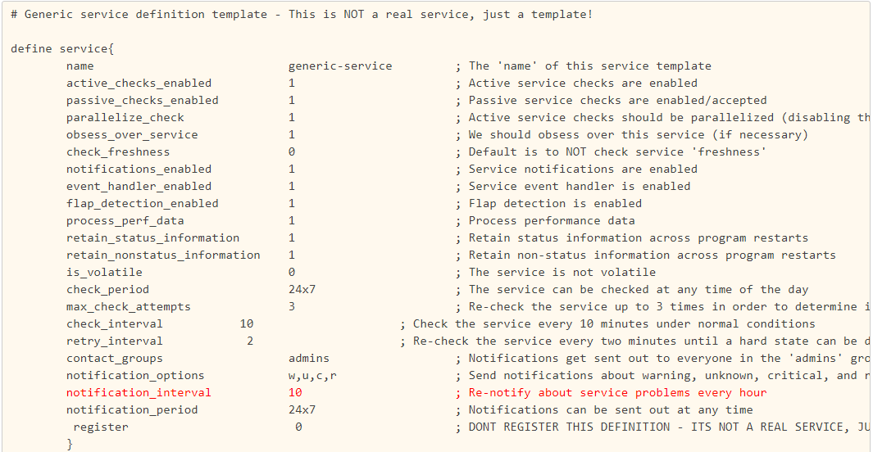](https://itadminsbraindump.files.wordpress.com/2020/01/nagios-core-xi-notification-setup.png)

For Host notifications, modify red highlighted entry

[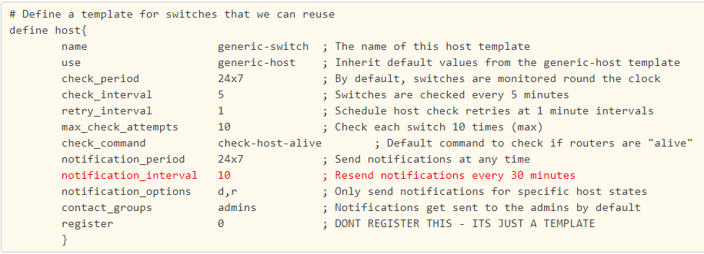](https://itadminsbraindump.files.wordpress.com/2020/01/nagios-xi-gmail-postfix-configurations.png)

In the end run below command and set password for nagiosadmin user

**sudo htpasswd -c /etc/nagios/htpasswd.users nagiosadmin**

Restart nagios service:

**sudo systemctl restart nagios.service**

Now you can access the web page with “**nagiosadmin**” and monitor all objects.

<http://ipaddressofserver/nagios>

**Share this:**

* [Twitter](https://itadminsbraindump.wordpress.com/2020/01/22/configure-nagios-email-notifications-in-aws-ec2-linux-server/?share=twitter&nb=1)
* [Facebook](https://itadminsbraindump.wordpress.com/2020/01/22/configure-nagios-email-notifications-in-aws-ec2-linux-server/?share=facebook&nb=1)

Related

[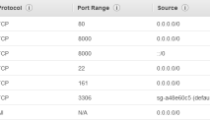](https://itadminsbraindump.wordpress.com/2020/01/21/configure-nagios-in-aws-ec2-linux-server/?relatedposts_hit=1&relatedposts_origin=649&relatedposts_position=0&relatedposts_hit=1&relatedposts_origin=649&relatedposts_position=0&relatedposts_hit=1&relatedposts_origin=649&relatedposts_position=0&relatedposts_hit=1&relatedposts_origin=649&relatedposts_position=0&relatedposts_hit=1&relatedposts_origin=649&relatedposts_position=0&relatedposts_hit=1&relatedposts_origin=649&relatedposts_position=0&relatedposts_hit=1&relatedposts_origin=649&relatedposts_position=0&relatedposts_hit=1&relatedposts_origin=649&relatedposts_position=0&relatedposts_hit=1&relatedposts_origin=649&relatedposts_position=0&relatedposts_hit=1&relatedposts_origin=649&relatedposts_position=0&relatedposts_hit=1&relatedposts_origin=649&relatedposts_position=0&relatedposts_hit=1&relatedposts_origin=649&relatedposts_position=0&relatedposts_hit=1&relatedposts_origin=649&relatedposts_position=0&relatedposts_hit=1&relatedposts_origin=649&relatedposts_position=0&relatedposts_hit=1&relatedposts_origin=649&relatedposts_position=0&relatedposts_hit=1&relatedposts_origin=649&relatedposts_position=0&relatedposts_hit=1&relatedposts_origin=649&relatedposts_position=0&relatedposts_hit=1&relatedposts_origin=649&relatedposts_position=0&relatedposts_hit=1&relatedposts_origin=649&relatedposts_position=0&relatedposts_hit=1&relatedposts_origin=649&relatedposts_position=0&relatedposts_hit=1&relatedposts_origin=649&relatedposts_position=0&relatedposts_hit=1&relatedposts_origin=649&relatedposts_position=0&relatedposts_hit=1&relatedposts_origin=649&relatedposts_position=0&relatedposts_hit=1&relatedposts_origin=649&relatedposts_position=0)

[**Configure Nagios in AWS EC2 Linux Server**](https://itadminsbraindump.wordpress.com/2020/01/21/configure-nagios-in-aws-ec2-linux-server/?relatedposts_hit=1&relatedposts_origin=649&relatedposts_position=0&relatedposts_hit=1&relatedposts_origin=649&relatedposts_position=0&relatedposts_hit=1&relatedposts_origin=649&relatedposts_position=0&relatedposts_hit=1&relatedposts_origin=649&relatedposts_position=0&relatedposts_hit=1&relatedposts_origin=649&relatedposts_position=0&relatedposts_hit=1&relatedposts_origin=649&relatedposts_position=0&relatedposts_hit=1&relatedposts_origin=649&relatedposts_position=0&relatedposts_hit=1&relatedposts_origin=649&relatedposts_position=0&relatedposts_hit=1&relatedposts_origin=649&relatedposts_position=0&relatedposts_hit=1&relatedposts_origin=649&relatedposts_position=0&relatedposts_hit=1&relatedposts_origin=649&relatedposts_position=0&relatedposts_hit=1&relatedposts_origin=649&relatedposts_position=0&relatedposts_hit=1&relatedposts_origin=649&relatedposts_position=0&relatedposts_hit=1&relatedposts_origin=649&relatedposts_position=0&relatedposts_hit=1&relatedposts_origin=649&relatedposts_position=0&relatedposts_hit=1&relatedposts_origin=649&relatedposts_position=0&relatedposts_hit=1&relatedposts_origin=649&relatedposts_position=0&relatedposts_hit=1&relatedposts_origin=649&relatedposts_position=0&relatedposts_hit=1&relatedposts_origin=649&relatedposts_position=0&relatedposts_hit=1&relatedposts_origin=649&relatedposts_position=0&relatedposts_hit=1&relatedposts_origin=649&relatedposts_position=0&relatedposts_hit=1&relatedposts_origin=649&relatedposts_position=0&relatedposts_hit=1&relatedposts_origin=649&relatedposts_position=0&relatedposts_hit=1&relatedposts_origin=649&relatedposts_position=0)

January 21, 2020

In "Brain Dump"

[](https://itadminsbraindump.wordpress.com/2010/01/25/microsoft-server-200020032008-dns-installation/?relatedposts_hit=1&relatedposts_origin=649&relatedposts_position=1&relatedposts_hit=1&relatedposts_origin=649&relatedposts_position=1&relatedposts_hit=1&relatedposts_origin=649&relatedposts_position=1&relatedposts_hit=1&relatedposts_origin=649&relatedposts_position=1&relatedposts_hit=1&relatedposts_origin=649&relatedposts_position=1&relatedposts_hit=1&relatedposts_origin=649&relatedposts_position=1&relatedposts_hit=1&relatedposts_origin=649&relatedposts_position=1&relatedposts_hit=1&relatedposts_origin=649&relatedposts_position=1&relatedposts_hit=1&relatedposts_origin=649&relatedposts_position=1&relatedposts_hit=1&relatedposts_origin=649&relatedposts_position=1&relatedposts_hit=1&relatedposts_origin=649&relatedposts_position=1&relatedposts_hit=1&relatedposts_origin=649&relatedposts_position=1&relatedposts_hit=1&relatedposts_origin=649&relatedposts_position=1&relatedposts_hit=1&relatedposts_origin=649&relatedposts_position=1&relatedposts_hit=1&relatedposts_origin=649&relatedposts_position=1&relatedposts_hit=1&relatedposts_origin=649&relatedposts_position=1&relatedposts_hit=1&relatedposts_origin=649&relatedposts_position=1&relatedposts_hit=1&relatedposts_origin=649&relatedposts_position=1&relatedposts_hit=1&relatedposts_origin=649&relatedposts_position=1&relatedposts_hit=1&relatedposts_origin=649&relatedposts_position=1&relatedposts_hit=1&relatedposts_origin=649&relatedposts_position=1&relatedposts_hit=1&relatedposts_origin=649&relatedposts_position=1&relatedposts_hit=1&relatedposts_origin=649&relatedposts_position=1&relatedposts_hit=1&relatedposts_origin=649&relatedposts_position=1)

[**Microsoft Server 2000/2003/2008 DNS Installation:**](https://itadminsbraindump.wordpress.com/2010/01/25/microsoft-server-200020032008-dns-installation/?relatedposts_hit=1&relatedposts_origin=649&relatedposts_position=1&relatedposts_hit=1&relatedposts_origin=649&relatedposts_position=1&relatedposts_hit=1&relatedposts_origin=649&relatedposts_position=1&relatedposts_hit=1&relatedposts_origin=649&relatedposts_position=1&relatedposts_hit=1&relatedposts_origin=649&relatedposts_position=1&relatedposts_hit=1&relatedposts_origin=649&relatedposts_position=1&relatedposts_hit=1&relatedposts_origin=649&relatedposts_position=1&relatedposts_hit=1&relatedposts_origin=649&relatedposts_position=1&relatedposts_hit=1&relatedposts_origin=649&relatedposts_position=1&relatedposts_hit=1&relatedposts_origin=649&relatedposts_position=1&relatedposts_hit=1&relatedposts_origin=649&relatedposts_position=1&relatedposts_hit=1&relatedposts_origin=649&relatedposts_position=1&relatedposts_hit=1&relatedposts_origin=649&relatedposts_position=1&relatedposts_hit=1&relatedposts_origin=649&relatedposts_position=1&relatedposts_hit=1&relatedposts_origin=649&relatedposts_position=1&relatedposts_hit=1&relatedposts_origin=649&relatedposts_position=1&relatedposts_hit=1&relatedposts_origin=649&relatedposts_position=1&relatedposts_hit=1&relatedposts_origin=649&relatedposts_position=1&relatedposts_hit=1&relatedposts_origin=649&relatedposts_position=1&relatedposts_hit=1&relatedposts_origin=649&relatedposts_position=1&relatedposts_hit=1&relatedposts_origin=649&relatedposts_position=1&relatedposts_hit=1&relatedposts_origin=649&relatedposts_position=1&relatedposts_hit=1&relatedposts_origin=649&relatedposts_position=1&relatedposts_hit=1&relatedposts_origin=649&relatedposts_position=1)

January 25, 2010

In "Brain Dump"

[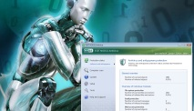](https://itadminsbraindump.wordpress.com/2010/04/24/download-and-configure-eset-nod32-antivirus-4-2-42-0/?relatedposts_hit=1&relatedposts_origin=649&relatedposts_position=2&relatedposts_hit=1&relatedposts_origin=649&relatedposts_position=2&relatedposts_hit=1&relatedposts_origin=649&relatedposts_position=2&relatedposts_hit=1&relatedposts_origin=649&relatedposts_position=2&relatedposts_hit=1&relatedposts_origin=649&relatedposts_position=2&relatedposts_hit=1&relatedposts_origin=649&relatedposts_position=2&relatedposts_hit=1&relatedposts_origin=649&relatedposts_position=2&relatedposts_hit=1&relatedposts_origin=649&relatedposts_position=2&relatedposts_hit=1&relatedposts_origin=649&relatedposts_position=2&relatedposts_hit=1&relatedposts_origin=649&relatedposts_position=2&relatedposts_hit=1&relatedposts_origin=649&relatedposts_position=2&relatedposts_hit=1&relatedposts_origin=649&relatedposts_position=2&relatedposts_hit=1&relatedposts_origin=649&relatedposts_position=2&relatedposts_hit=1&relatedposts_origin=649&relatedposts_position=2&relatedposts_hit=1&relatedposts_origin=649&relatedposts_position=2&relatedposts_hit=1&relatedposts_origin=649&relatedposts_position=2&relatedposts_hit=1&relatedposts_origin=649&relatedposts_position=2&relatedposts_hit=1&relatedposts_origin=649&relatedposts_position=2&relatedposts_hit=1&relatedposts_origin=649&relatedposts_position=2&relatedposts_hit=1&relatedposts_origin=649&relatedposts_position=2&relatedposts_hit=1&relatedposts_origin=649&relatedposts_position=2&relatedposts_hit=1&relatedposts_origin=649&relatedposts_position=2&relatedposts_hit=1&relatedposts_origin=649&relatedposts_position=2&relatedposts_hit=1&relatedposts_origin=649&relatedposts_position=2)

[**Download and configure ESET NOD32 Antivirus 7.0**](https://itadminsbraindump.wordpress.com/2010/04/24/download-and-configure-eset-nod32-antivirus-4-2-42-0/?relatedposts_hit=1&relatedposts_origin=649&relatedposts_position=2&relatedposts_hit=1&relatedposts_origin=649&relatedposts_position=2&relatedposts_hit=1&relatedposts_origin=649&relatedposts_position=2&relatedposts_hit=1&relatedposts_origin=649&relatedposts_position=2&relatedposts_hit=1&relatedposts_origin=649&relatedposts_position=2&relatedposts_hit=1&relatedposts_origin=649&relatedposts_position=2&relatedposts_hit=1&relatedposts_origin=649&relatedposts_position=2&relatedposts_hit=1&relatedposts_origin=649&relatedposts_position=2&relatedposts_hit=1&relatedposts_origin=649&relatedposts_position=2&relatedposts_hit=1&relatedposts_origin=649&relatedposts_position=2&relatedposts_hit=1&relatedposts_origin=649&relatedposts_position=2&relatedposts_hit=1&relatedposts_origin=649&relatedposts_position=2&relatedposts_hit=1&relatedposts_origin=649&relatedposts_position=2&relatedposts_hit=1&relatedposts_origin=649&relatedposts_position=2&relatedposts_hit=1&relatedposts_origin=649&relatedposts_position=2&relatedposts_hit=1&relatedposts_origin=649&relatedposts_position=2&relatedposts_hit=1&relatedposts_origin=649&relatedposts_position=2&relatedposts_hit=1&relatedposts_origin=649&relatedposts_position=2&relatedposts_hit=1&relatedposts_origin=649&relatedposts_position=2&relatedposts_hit=1&relatedposts_origin=649&relatedposts_position=2&relatedposts_hit=1&relatedposts_origin=649&relatedposts_position=2&relatedposts_hit=1&relatedposts_origin=649&relatedposts_position=2&relatedposts_hit=1&relatedposts_origin=649&relatedposts_position=2&relatedposts_hit=1&relatedposts_origin=649&relatedposts_position=2)

April 24, 2010

In "Brain Dump"

* **Tagged**
* [gmail notification email configuration postfix setup nagios gmail app parrword for nagios](https://itadminsbraindump.wordpress.com/tag/gmail-notification-email-configuration-postfix-setup-nagios-gmail-app-parrword-for-nagios/)



**Published by Dharamvir's Braindump**

*I am Network Support Expert in Chandigarh.*[*View all posts by Dharamvir's Braindump*](https://itadminsbraindump.wordpress.com/author/sangramsystems/)

**Published**January 22, 2020

Post navigation

[Previous Post Configure Nagios in AWS EC2 Linux Server](https://itadminsbraindump.wordpress.com/2020/01/21/configure-nagios-in-aws-ec2-linux-server/)

Leave a Reply

Top of Form



Bottom of Form

**Datewise Posts**

| January 2020 | | | | | | |
| --- | --- | --- | --- | --- | --- | --- |
| **M** | **T** | **W** | **T** | **F** | **S** | **S** |
|  | | 1 | 2 | 3 | 4 | 5 |
| 6 | 7 | 8 | 9 | 10 | 11 | 12 |
| 13 | 14 | 15 | 16 | 17 | 18 | 19 |
| 20 | [21](https://itadminsbraindump.wordpress.com/2020/01/21/) | [22](https://itadminsbraindump.wordpress.com/2020/01/22/) | 23 | 24 | 25 | 26 |
| 27 | 28 | 29 | 30 | 31 |  | |

[« Aug](https://itadminsbraindump.wordpress.com/2017/08/)

**Email Subscription**

Top of Form

Enter your email address to subscribe to this blog and receive notifications of new posts by email.

Join 21 other followers

Email Address:

Sign me up!

Bottom of Form

**Categories**

* [Brain Dump](https://itadminsbraindump.wordpress.com/category/brain-dump/) (36)
* [Drivers](https://itadminsbraindump.wordpress.com/category/drivers/) (6)
* [Ubuntu/Lubuntu](https://itadminsbraindump.wordpress.com/category/ubuntulubuntu/) (5)

**Recent Posts**

* [**Configure Nagios Email Notifications in AWS EC2 Linux Server**](https://itadminsbraindump.wordpress.com/2020/01/22/configure-nagios-email-notifications-in-aws-ec2-linux-server/)
* [**Configure Nagios in AWS EC2 Linux Server**](https://itadminsbraindump.wordpress.com/2020/01/21/configure-nagios-in-aws-ec2-linux-server/)
* [**Error- No Application Found in Software Center of Ubuntu or Lubuntu 17.04**](https://itadminsbraindump.wordpress.com/2017/08/05/error-no-application-found-in-software-center-of-ubuntu-or-lubuntu-17-04/)
* [**How to Install SPARK 2.8.3 IM for OPENFIRE in UBUNTU or LUBUNTU 17.04 (Any Version)**](https://itadminsbraindump.wordpress.com/2017/08/04/how-to-install-spark-2-8-3-im-for-openfire-in-ubuntu-or-lubuntu-17-04-any-version/)
* [**How to Install or Upgrade SUBLIME Text latest on Ubuntu or Lubuntu 17.04 (or any version)**](https://itadminsbraindump.wordpress.com/2017/08/04/how-to-install-or-upgrade-sublime-text-latest-on-ubuntu-or-lubuntu-17-04-or-any-version/)
* [**How to downgrade from PHP7.0 to PHP5.6 in Ubuntu or Lubuntu**](https://itadminsbraindump.wordpress.com/2017/08/03/how-to-downgrade-from-php7-0-to-php5-6-in-ubuntu-or-lubuntu/)
* [**How to Install LAMP, PHP 7.0, MySQL and PHPMyadmin on UBUNTU or Lubuntu 17**](https://itadminsbraindump.wordpress.com/2017/08/02/how-to-install-lamp-php-7-0-mysql-and-phpmyadmin-on-ubuntu-or-lubuntu-17/)
* [**How to Share Folder in MAC and Access that on Windows PC**](https://itadminsbraindump.wordpress.com/2014/06/10/how-to-share-folder-in-mac-and-access-that-on-windows-pc/)
* [**How to Share Microsoft Windows folder and Access that on MAC PC**](https://itadminsbraindump.wordpress.com/2014/06/10/how-to-share-microsoft-windows-folder-and-access-that-on-mac-pc/)
* [**How to transfer Music to iPhone, iPad or in iPod.**](https://itadminsbraindump.wordpress.com/2014/05/13/how-to-transfer-music-to-iphone-ipad-or-in-ipod/)
* [**IDE to Multi-SATA Connector**](https://itadminsbraindump.wordpress.com/2010/06/19/ide-to-multi-sata-connector/)
* [**Download ASRock Motherboard P4i45GV with FW82801DB, Realtek RTL8101L LAN DRIVER and C-Media Audio Drivers**](https://itadminsbraindump.wordpress.com/2010/05/20/download-asrock-motherboard-p4i45gv-with-fw82801db-realtek-rtl8101l-lan-driver-and-c-media-audio-drivers/)
* [**Coolmax PS-228-Power Supply Tester with LCD**](https://itadminsbraindump.wordpress.com/2010/05/16/coolmax-ps-228-power-supply-tester-with-lcd/)
* [**Download Asus P5GC-TVM-SE/S motherboard drivers with Realtek ALC Audio, Intel ICH7R Graphics Adapter 6.14, SiS USB 2.0, RTL8110SC LAN card SiS Adapter.**](https://itadminsbraindump.wordpress.com/2010/05/10/download-asus-p5gc-tvm-ses-motherboard-drivers-with-realtek-alc-audio-intel-ich7r-graphics-adapter-6-14-sis-usb-2-0-rtl8110sc-lan-card-sis-adapter/)
* [**Crack/Patch to activate Windows 7? just remove WAT**](https://itadminsbraindump.wordpress.com/2010/05/09/crackpatch-to-activate-windows-7-just-remove-wat/)

[Blog at WordPress.com.](https://wordpress.com/?ref=footer_blog)